7th Lab – RIP based FLSM Network (Large Subnet Design)

Task:
Subnet the following:
172.19.0.0/16
Network: 10
Host: 20
- Create IP allocation table
- Configure Topology

Topology Example

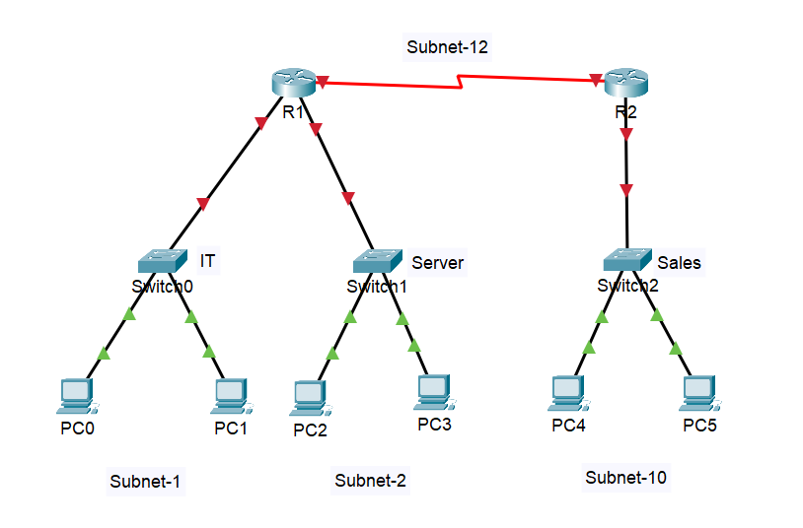
- IP allocation Table
Network: 10
Host: 20
Address: 172.19.0.0/16

- Solution:
Network: 2⁴ = 16
Host: 2¹²-2 = 4094
Block Size: 2⁴ = 16
Table:
Subnet No. | Network Address (N.A) | Broadcast Address (B.A) | Valid Host IP  (Address Range)
1st | 172.19.0.0 | 172.19.15.255 | 172.19.0.01 - 172.19.15.254
2nd | 172.19.16.0 | 172.19.31.255 | 172.19.16.01 - 172.19.31.254
3rd | 172.19.32.0 | 172.19.47.255 | 172.19.32.01 - 172.19.47.254
4th | 172.19.48.0 | 172.19.63.255 | 172.19.48.01 - 172.19.63.254
5th | 172.19.64.0 | 172.19.79.255 | 172.19.64.01 - 172.19.79.254
6th | 172.19.80.0 | 172.19.95.255 | 172.19.80.01 - 172.19.95.254
7th | 172.19.96.0 | 172.19.111.255 | 172.19.96.01 - 172.19.111.254
8th | 172.19.112.0 | 172.19.127.255 | 172.19.112.01 - 172.19.127.254
9th | 172.19.128.0 | 172.19.143.255 | 172.19.128.01 - 172.19.143.254
10th | 172.19.144.0 | 172.19.159.255 | 172.19.144.01 - 172.19.159.254
11th | 172.19.160.0 | 172.19.175.255 | 172.19.160.01 - 172.19.175.254
12th | 172.19.176.0 | 172.19.191.255 | 172.19.176.01 - 172.19.191.254
13th | 172.19.192.0 | 172.19.207.255 | 172.19.192.01 - 172.19.207.254
14th | 172.19.208.0 | 172.19.223.255 | 172.19.208.01 - 172.19.223.254
15th | 172.19.224.0 | 172.19.239.255 | 172.19.224.01 - 172.19.239.254
16th | 172.19.240.0 | 172.19.255.255 | 172.19.240.01 - 172.19.255.254
Custom Subnet Mask: 255.255.240.0
CIDR: /20

Topology
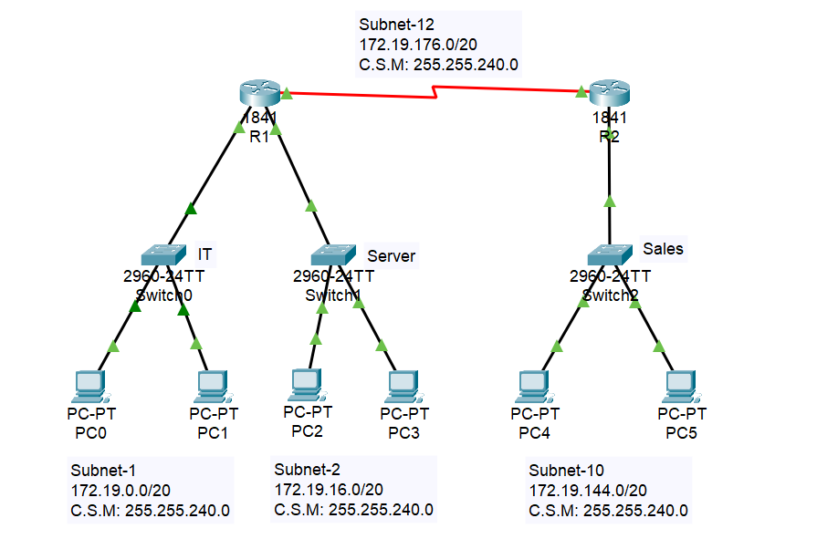
- Network Summary
Switch Name | Subnet | Connected PCs
Switch0 (IT) | 172.19.0.0/20 | PC0, PC1
Switch1 (Server) | 172.19.16.0/20 | PC2, PC3
Switch2 (Sales) | 172.19.144.0/20 | PC4, PC5
Serial Link | 172.19.176.0/20 | R1 ↔ R2
- Router Configuration
Router R1
Router> enable
Router# configure terminal
Router(config)# hostname R1
R1(config)# interface fastethernet 0/0
R1(config-if)# ip address 172.19.0.1 255.255.240.0
R1(config-if)# no shutdown
R1(config-if)# exit
R1(config)# ip dhcp pool IT
R1(dhcp-config)# network 172.19.0.0 255.255.240.0
R1(dhcp-config)# default-router 172.19.0.1
R1(dhcp-config)# exit
R1(config)# interface fastethernet 0/1
R1(config-if)# ip address 172.19.16.1 255.255.240.0
R1(config-if)# no shutdown
R1(config-if)# exit
R1(config)# ip dhcp pool Server
R1(dhcp-config)# network 172.19.16.0 255.255.240.0
R1(dhcp-config)# default-router 172.19.16.1
R1(dhcp-config)# exit
R1(config)# interface serial 0/0/0
R1(config-if)# ip address 172.19.176.1 255.255.240.0
R1(config-if)# clock rate 148000
R1(config-if)# no shutdown
R1(config-if)# exit
R1(config)# router rip
R1(config-router)# network 172.19.0.0
R1(config-router)# network 172.19.16.0
R1(config-router)# network 172.19.176.0
R1(config-router)# no auto-summary
R1(config)# Ctrl+Z
R1# write
Router R2
Router> enable
Router# configure terminal
Router(config)# hostname R2
R2(config)# interface fastethernet 0/0
R2(config-if)# ip address 172.19.144.1 255.255.240.0
R2(config-if)# no shutdown
R2(config-if)# exit
R2(config)# ip dhcp pool Sales
R2(dhcp-config)# network 172.19.144.0 255.255.240.0
R2(dhcp-config)# default-router 172.19.144.1
R2(dhcp-config)# exit
R2(config)# interface serial 0/0/1
R2(config-if)# ip address 172.19.176.2 255.255.240.0
R2(config-if)# no shutdown
R2(config-if)# exit
R2(config)# router rip
R2(config-router)# network 172.19.144.0
R1(config-router)# network 172.19.176.0
R2(config-router)# exit
R2(config)# Ctrl+Z
R2# write
- PC Configuration (PC0–PC5)
- Click on each PC (e.g., PC0).
- Go to Desktop tab > IP Configuration.
- Select DHCP.
- The PC will receive:
- IP Address
- Subnet Mask
- Default Gateway (from router)

